**Tanggal :**

**DEALER :**

**TANDA TERIMA**

|  |  |  |  |
| --- | --- | --- | --- |
| **No** | **Nama Barang** | **Jumlah** | **Ket** |
| 1 |  |  |  |
| 2 |  |  |  |
| 3 |  |  |  |
| 4 |  |  |  |
| 5 |  |  |  |
| 6 |  |  |  |
| 7 |  |  |  |

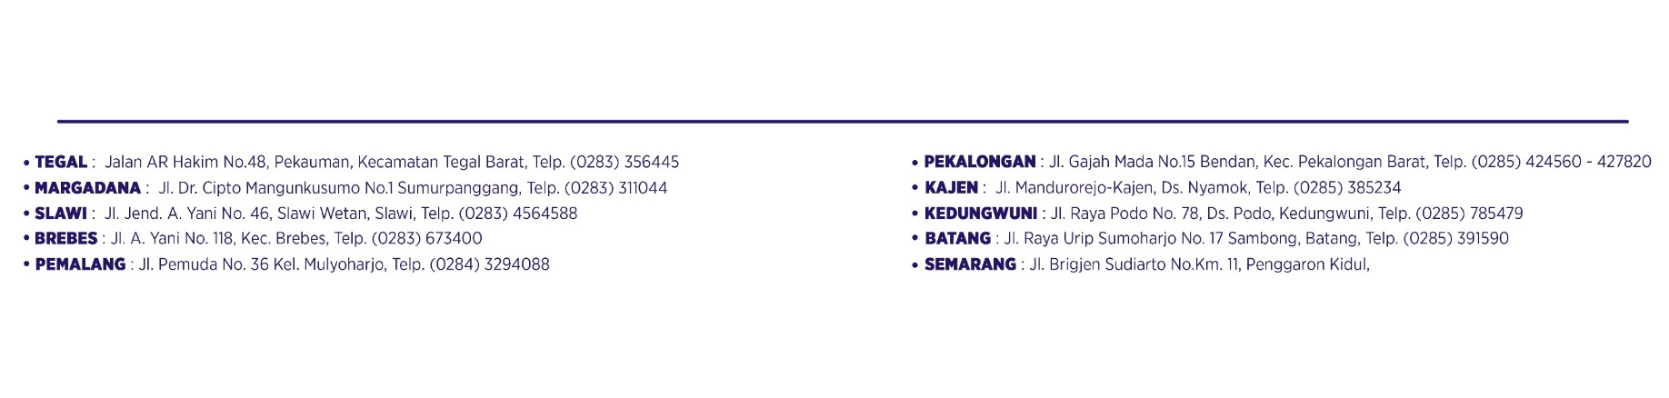

|  |  |
| --- | --- |
| Diserahkan | Diterima, |
|  |  |
| ( ) | ( ) |

✂

**DEALER :**



**Tanggal :**

**TANDA TERIMA**

|  |  |  |  |  |
| --- | --- | --- | --- | --- |
| **No** | **Nama Barang** | **Jumlah** | | **Ket** |
| 1 |  |  | |  |
| 2 |  |  | |  |
| 3 |  |  | |  |
| 4 |  |  | |  |
| 5 |  |  | |  |
| 6 |  |  | |  |
| 7 |  |  | |  |
| Diserahkan | | | Diterima, | |
|  | | |  | |
| ( ) | | | ( ) | |

**Tanggal :18/10/2022**

**DEALER : Central Tegal**

**TANDA TERIMA**

|  |  |  |  |
| --- | --- | --- | --- |
| **No** | **Nama Barang** | **Jumlah** | **Ket** |
| 1 | Printer EPSON L3210 | 1 |  |
| 2 |  |  |  |
| 3 |  |  |  |



|  |  |
| --- | --- |
| Diserahkan | Diterima, |
|  |  |
| Yudas seloardhi | Tiwi/Fina |

✂

**DEALER : Central Tegal**



**Tanggal : 18/10/2022**

**TANDA TERIMA**

|  |  |  |  |  |
| --- | --- | --- | --- | --- |
| **No** | **Nama Barang** | **Jumlah** | | **Ket** |
| 1 | Printer EPSON L3210 | 1 | |  |
| 2 |  |  | |  |
| 3 |  |  | |  |
| Diserahkan | | | Diterima, | |
|  | | |  | |
| Yudas seloardhi | | | Tiwi/Fina | |

**Tanggal :**

**DEALER :**

**TANDA TERIMA**

|  |  |  |  |
| --- | --- | --- | --- |
| **No** | **Nama Barang** | **Jumlah** | **Ket** |
| 1 |  |  |  |
| 2 |  |  |  |
| 3 |  |  |  |
| 4 |  |  |  |
| 5 |  |  |  |
| 6 |  |  |  |
| 7 |  |  |  |



|  |  |
| --- | --- |
| Diserahkan | Diterima |
|  |  |
| ( ) | ( ) |

✂



**DEALER :**

**Tanggal :**

**TANDA TERIMA**

|  |  |  |  |  |
| --- | --- | --- | --- | --- |
| **No** | **Nama Barang** | **Jumlah** | | **Ket** |
| 1 |  |  | |  |
| 2 |  |  | |  |
| 3 |  |  | |  |
| 4 |  |  | |  |
| 5 |  |  | |  |
| 6 |  |  | |  |
| 7 |  |  | |  |
| Diserahkan | | | Diterima | |
|  | | |  | |
| ( ) | | | ( ) | |